**MAIL SERVICE INSTALLATION AND CONFIGURATION ON LINUX PLATFORM**

In order to run a mail service on Linux based server we use the following services to run the mail services:

* **POSTFIX**: It is a Mail transfer agent which is used to send the mail between users.
* **DOVECOT** : It is used as a Mail delivery agent which is used to receive the mails in the end users mailbox
* **MUTT** : It is the Mail user agent that is used for overall operations of the mail server

**Installation of postfix:**

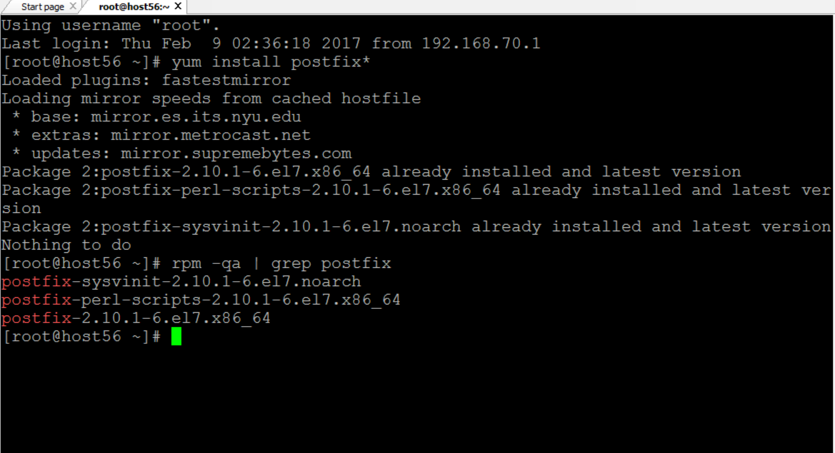

Postfix is installed using the YUM package installer that installs all the packages required to run the particular service along with all the dependencies that are associated with a particular package. **Command used : yum install postfix\***

**Installation of dovecot**

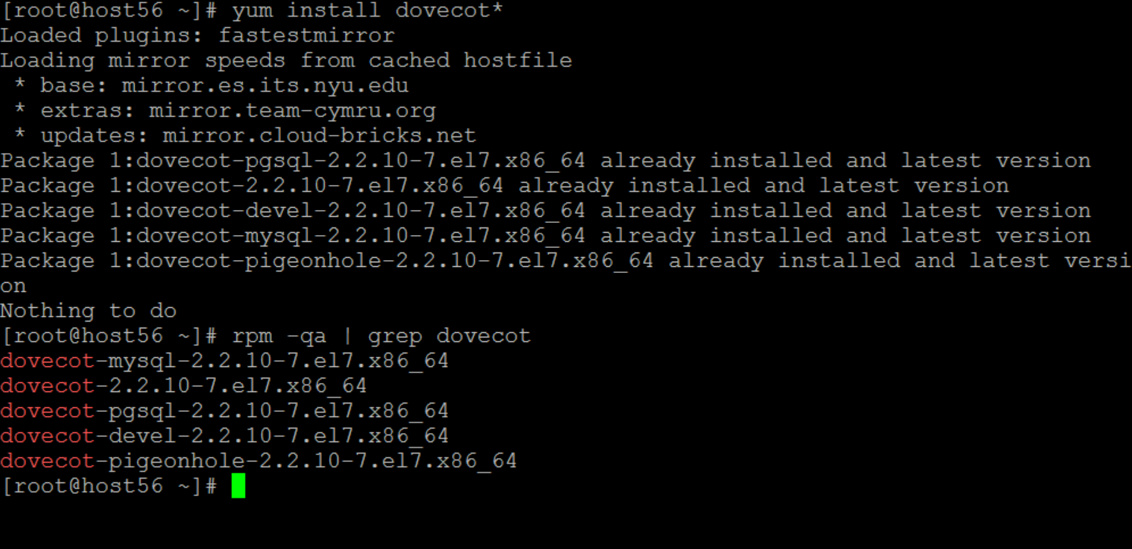

Dovecot is also installed using the YUM package installer.

**Command used: yum install dovecot\***

**Installation of MUTT**

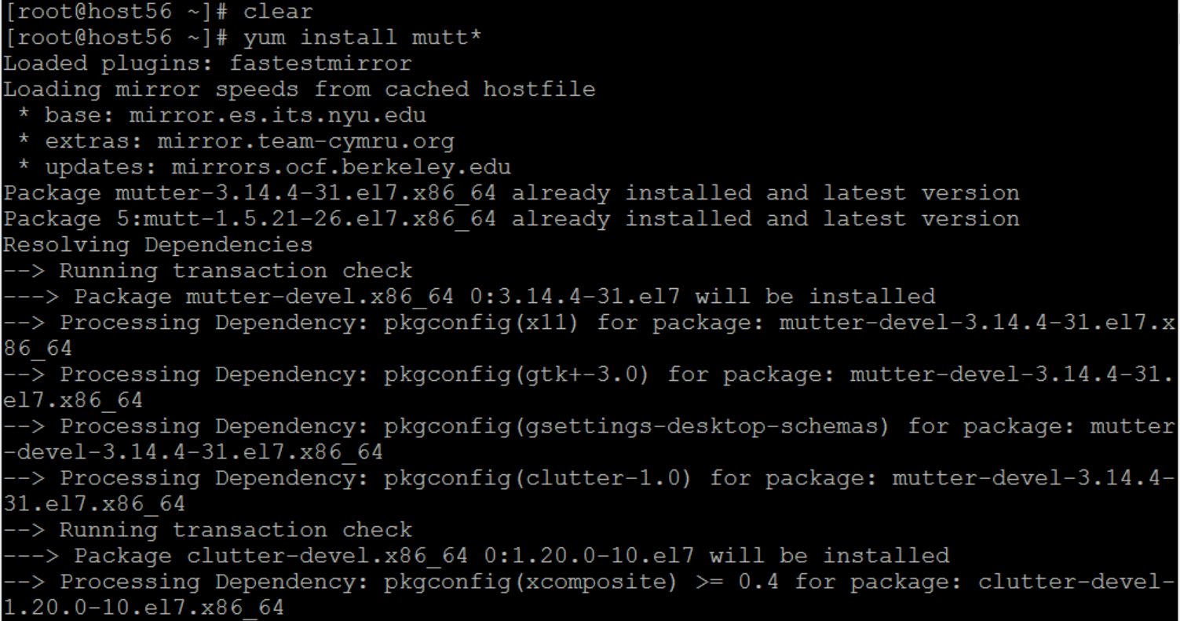

Mutt is also installed using the YUM package installer using command **yum install mutt\***

**CONFIGURATION:**

We need to configure the postfix directory in the **/etc** directory

Entry to /etc/postfix:

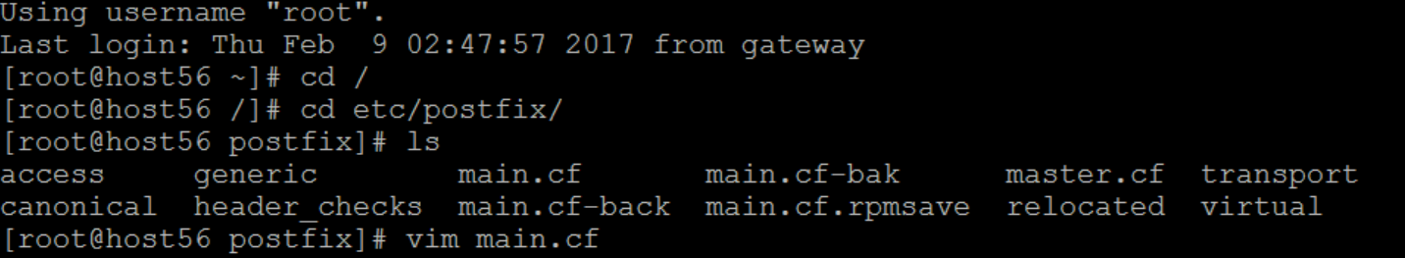

**Configure main.conf:**

In the main.conf file we need to set the mail transfer agent and the hostname of the server for which the mail service is being configured.

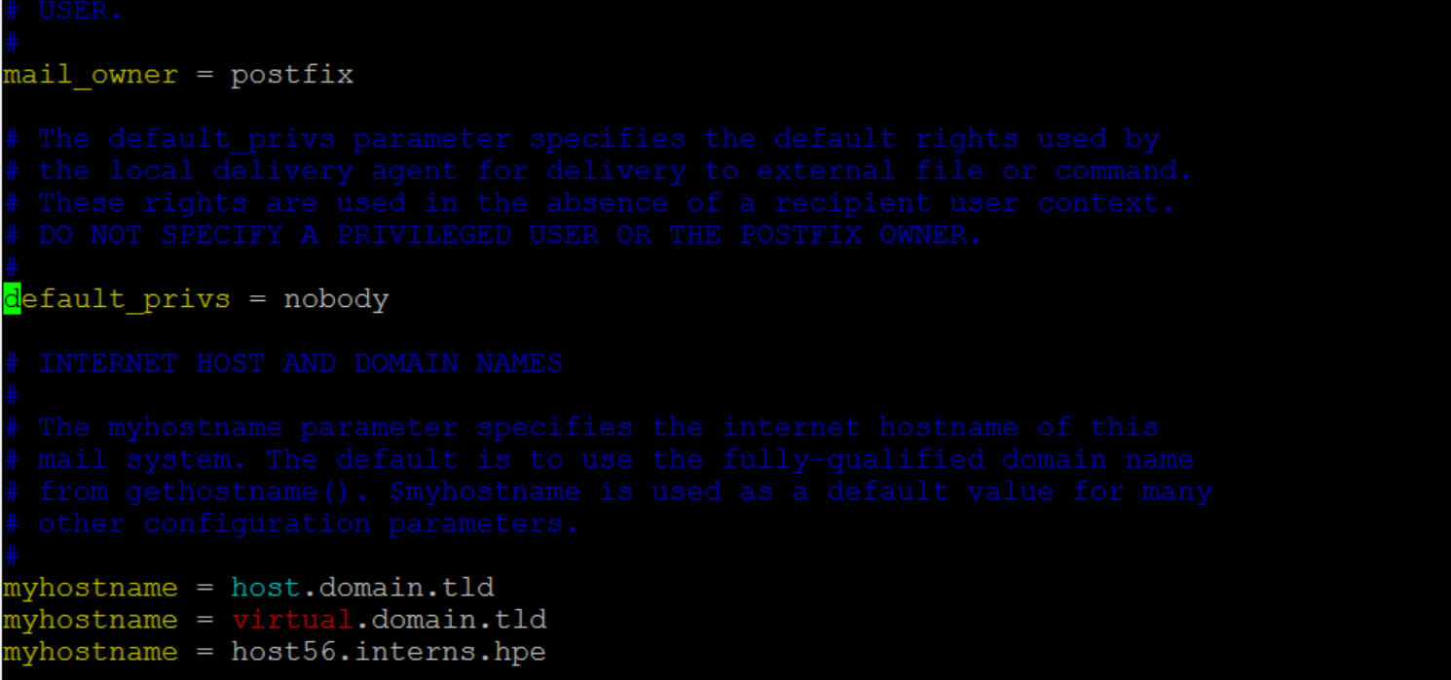

Specify all the necessary interface rules and specify the different protocols to be used by MTA

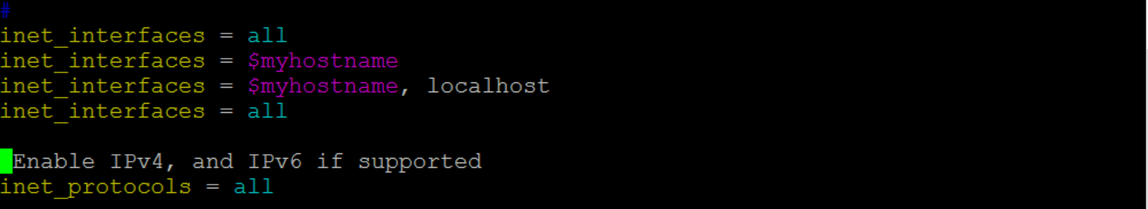

Go to /etc/dovecot/dovecot.conf

And change or specify the required protocols in dovecot.conf file:

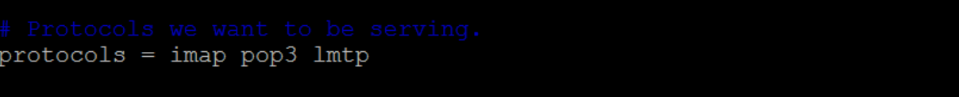

**Inside conf.d directory:**

Open 10-mail.conf file to set or change the mail directory location.

Change mail location

Each user can specify his own mail directory location but it has to be updated in the configuration file of the DOVECOT service.

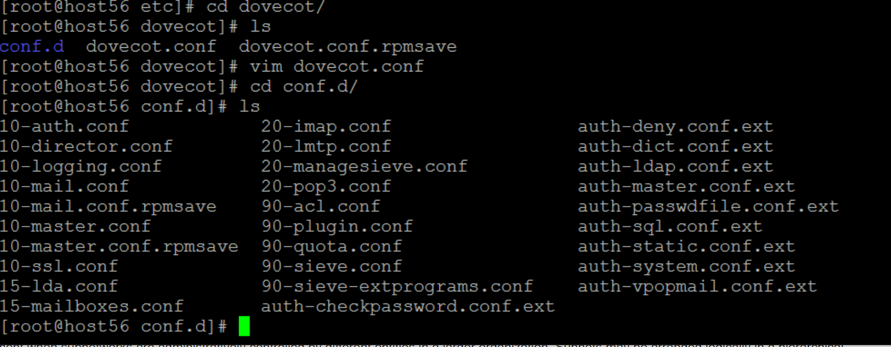

Specify the mail directory that should used for each user to store the incoming mails. This directory will serve as the mailbox for the user.

10-mail.conf is the configuration file that stores the location of the mail inbox directory and redirects all the mails to that specific directory.



**Change user groups in 10-master.conf:**

This configuration is to make sure that both users and groups use the same MTA for the service.

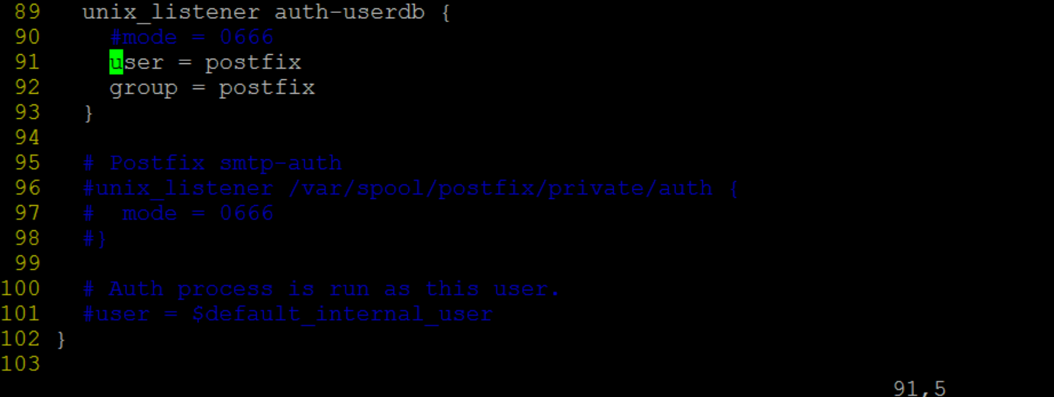

**Switch user to beta and check mail**

Now we switch the user account to check whether the test mail that we have sent has been received by the desired user or not. In this case we switch to a user named beta that serves as the mail receiver.

We can find the mail in the home/Maildir/new directory of the user beta.

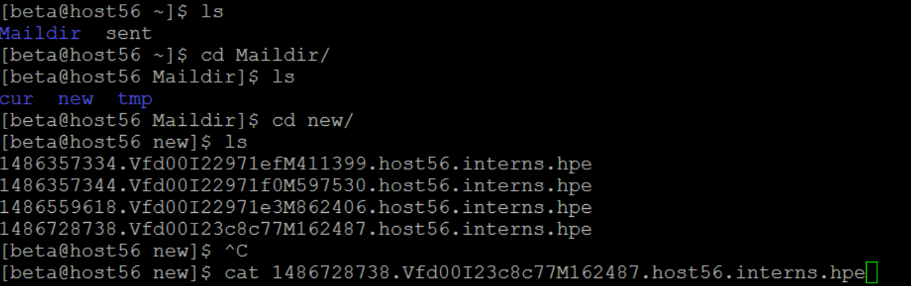

Open the mail using command cat command . The mail details are as follows :

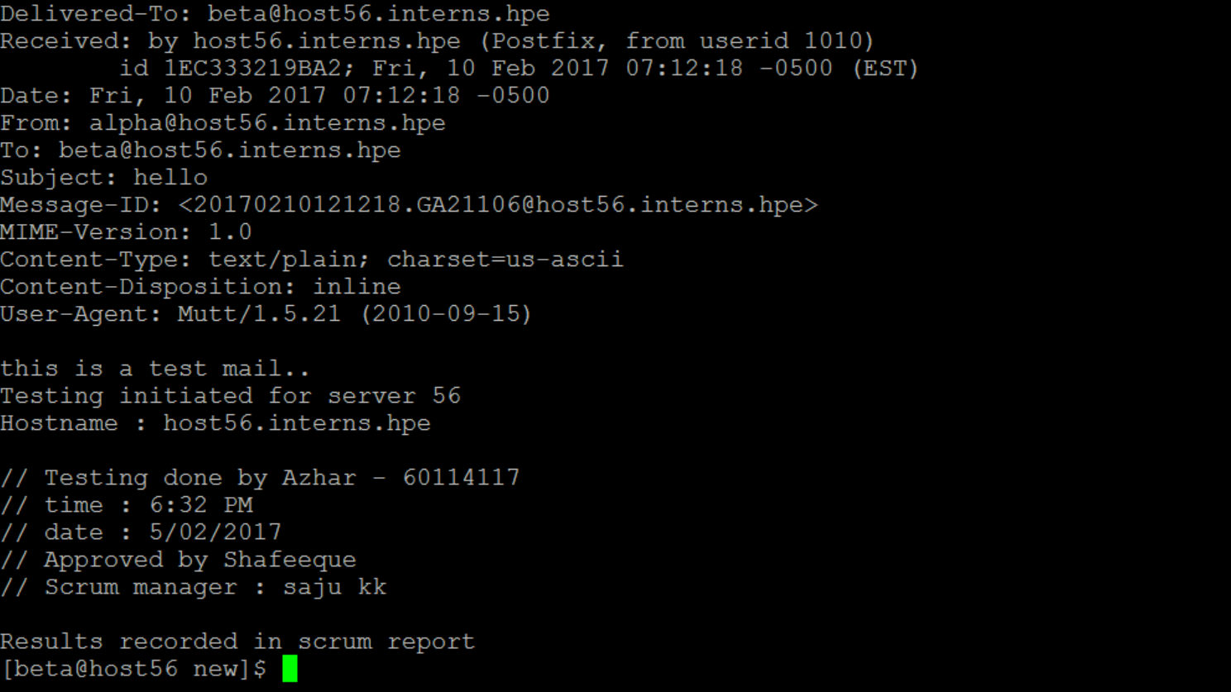

***We have configured the mail service for 16 servers that will be serving different purposes in the course of the project.***